**Hardware-software object tracking system using a moving camera**

**Michał Daniłowicz**

**michaldanilow@gmail.com**

**Submitted for the 2019 Digilent Design Contest Europe**

**03.05.2019**

**Advisor: Tomasz Kryjak, PhD**

**AGH University of Science and Technology**

**Kraków, Poland**

**{Photo of the project}**

**{Photo of the team members}**

(These can be combined, so long as everything is clearly identifiable)

# {Your “Product Marketing Sheet” Goes Here}

# Introduction

Tracking problem is finding the tracked object in each frame of video sequence. Object’s velocity can also be calculated. Video tracking system can be used in many applications:

* Security – tracking vehicles and people in video surveillance systems,
* Entertainment – player controls in VR games via body movements,
* Autonomous vehicles – park assist, road signs and pedestrians tracking,
* Military – scout drones, aim assist

**Abstract**

Vision tracking algorithm was implemented in programmable logic of Zynq SoC. Used IP camera is mounted on moving head with pan/tilt position adjustments. The system controls camera’s position via TCP connection so that the tracked object is positioned in the center of each video frame.

**Objectives**

* Controlling camera’s position with HTTP requests,
* Implementation of skin color tracking algorithm in FPGA,
* Sending HTTP requests via Zybo processing system,
* Connecting FPGA with processing system via AXI Lite interface,
* Implementation of KLT tracking algorithm,
* Implementation of pyramidal version of KLT algorithm

**Project Summary**

The project can be divided into two main parts, vision tracking algorithm implemented in FPGA and camera control system implemented in processing system of Zybo (ARM microcontroller). The camera’s response time is short enough for tracking moving objects like moving people or body parts. Implemented KLT algorithm tracks one point of video stream. The design can be used in many applications, as the camera can be controlled via internet connection.

**Digilent Products Required**

Zybo Z7-20 development board.

**Tools Required**

IP camera with HTTP pan/tilt position control,

Vivado/SDK environment,

Ethernet switch and cables

**Design Status**

Point tracking was successfully implemented, but for robust tracking, Harris corner detector should be implemented for finding best points candidates. Point clustering should also be implemented in order to track actual object, not just points in video sequence.

# Background

**Why This Project?**

Insert text here.

**Reference Material**

Pyramidal Implementation of the Lucas Kanade Feature Tracker Description of the algorithm - <https://web.stanford.edu/class/cs231m/references/pyr-lucas-kanade-feature-tracker-bouget.pdf>

## Design

**Features and Specifications**

Insert text here.

**Design Overview**

Project’s block diagram is shown on Figure 1. The processing system is responsible for sending requests on TCP port 80 (HTTP) that control camera’s pan/tilt position and for that purpose, Xilinx TCP client project example was used. The network code was extended by features needed for the design, like manual reconnection with TCP server, manual disconnection and HTTP request generation. Two P-type regulators were also implemented in the processing system, one for “x” axis and one for “y” axis. The programmable logic (FPGA) implements video tracking algorithm and uses HDMI port as input. Communication between ARM and FPGA is done via AXI4 interface.

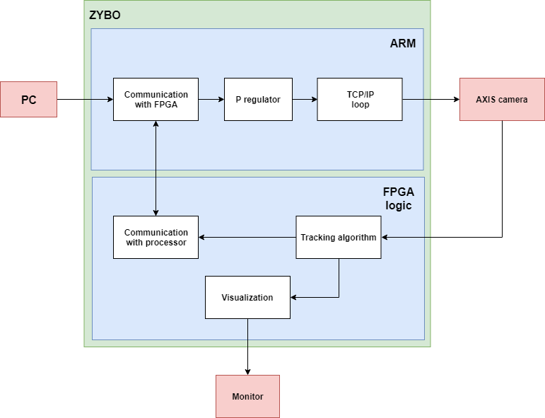

Figure 1. System diagram

**Detailed Design Description**

In following design description, we consider $i$ pixel coordinate as row index and $j$ pixel coordinate as column index, starting at [1, 1] for the upper left corner pixel.

**Controlling camera position**

Camera’s server accepts HTTP requests with following structure:

<camera_ip_address>/axis-cgi/com/ptz.cgi?<parameter>=<value>

For example, to set x-axis velocity to 40% and y-axis velocity to -20% of a camera with IP address 192.168.1.7, the following request should be sent:

192.168.1.7/axis-cgi/com/ptz.cgi?continuouspantiltmove=40,-20

**Skin color tracking**

For testing camera’s response time, a relatively simple skin color tracking algorithm was implemented in programmable logic of the SoC. General block diagram is shown on Figure 2.

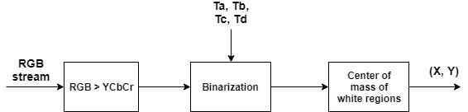

Figure 2. Skin color tracking

Video processing begins with conversion to $YC_{b}C_{r}$ color space. Input RGB pixel is converted as follows:

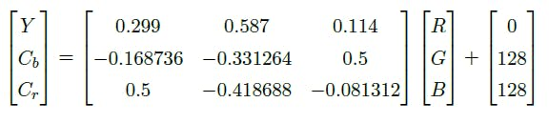

Skin color can be defined as some rectangle in two-dimensional $[C_{b}, C_{r}]$ space:

$$class= \left\{\begin{aligned}255 if C_{b}∈\left[T_{a}, T_{b}\right] and C_{r}∈[T_{c}, T_{d}] \\ 0 otherwise \end{aligned}\right.$$

255 pixel value is considered a skin color pixel and $(T_{a}, T_{b}, T_{c}, T_{d})$ values are found experimentally. Notice that we are not taking $Y$ component (brightness) into account, because we want this classification to be independent (to some extent) from lighting. After classification, center coordinates of skin regions can be calculated:

$$x=\frac{M_{x}}{\sum_{i}{\sum_{j}{I(i, j)}}}$$

$$y=\frac{M_{y}}{\sum_{i}{\sum_{j}{I(i, j)}}}$$

Where:

$$M_{x}=\sum_{i}{\sum_{j}{j∙I(i, j)}}$$

$$M_{y}=\sum_{i}{\sum_{j}{i∙I(i, j)}}$$

$I(i, j)$ is class value for $(i, j)$ pixel coordinates.

The most interesting part of skin color tracking implementation in FPGA is calculating $(x, y)$ coordinates of skin color center of mass. The general block diagram of the module that does the work is shown on Figure 3. The module’s name in project files is $centroid$.

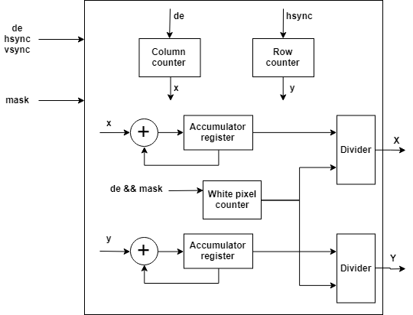

Figure 3. Centroid module

**KLT tracking algorithm**

**Pyramidal KLT tracking**

## Discussion

**Problems Encountered**

Insert text here.

**Engineering Resources Used**

Insert text here.

**Marketability**

Insert text here.

**Community Feedback**

Insert text here.

## References

Insert text here.

# Appendix A: {Name of Source Code File}

Insert text here.